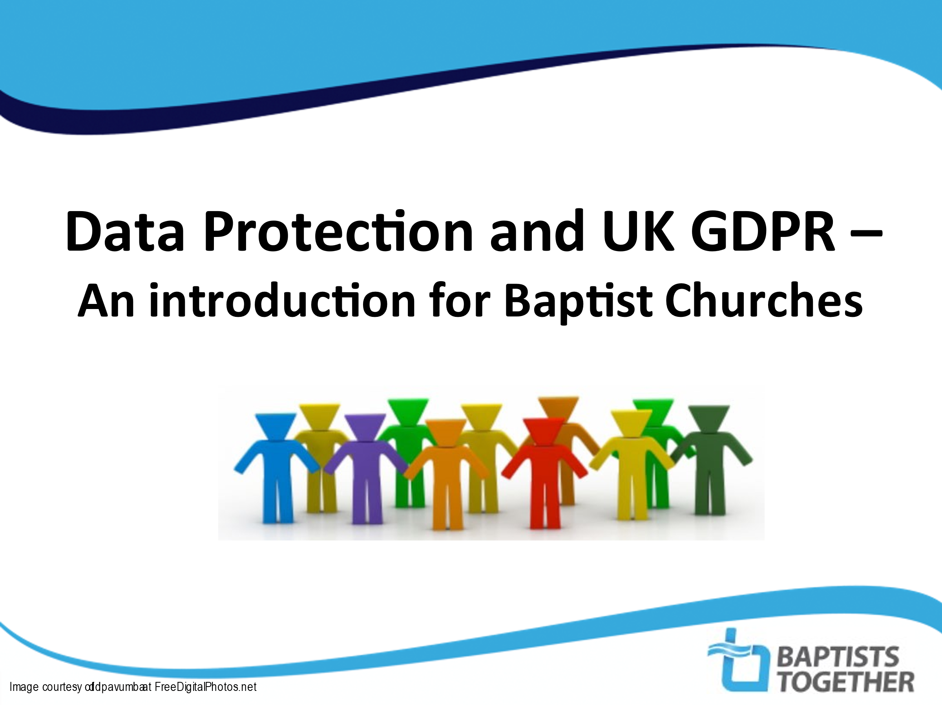 | SCRIPT: The UK General Data Protection Regulation and the Data Protection Act 2018affect all organisations (including our church) which process personal data in some way. Data Protection can seem quite technical but we need to think about this as ‘People Protection’. But why is this important for us as a church?
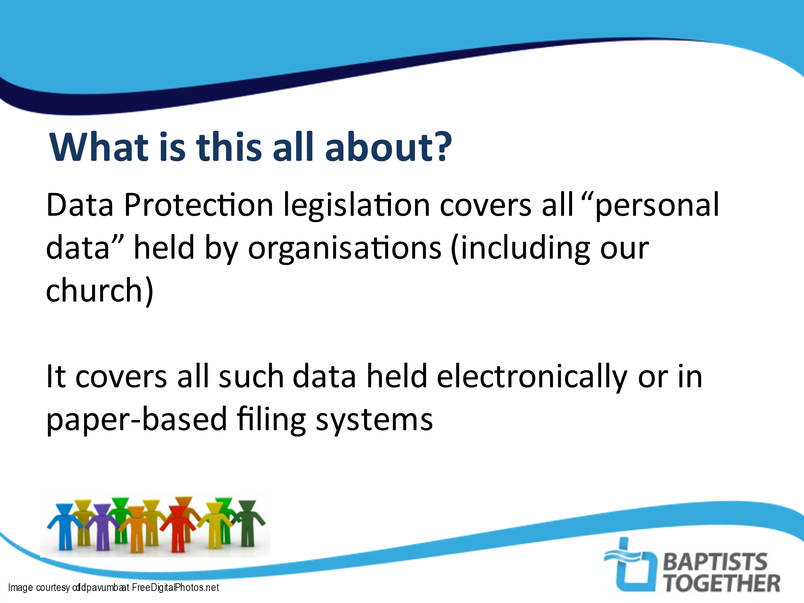 | SCRIPT:  (Read from slide)  NOTES: For reference – page 4 of the L13 Guideline leaflet expands on this
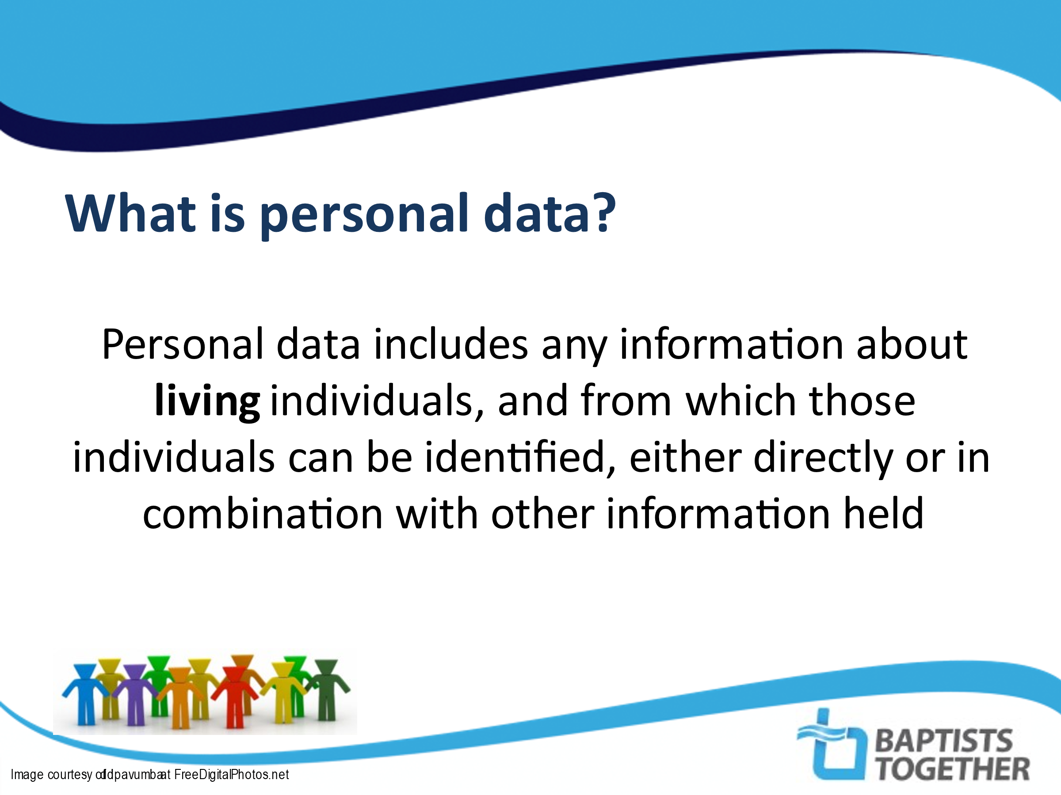  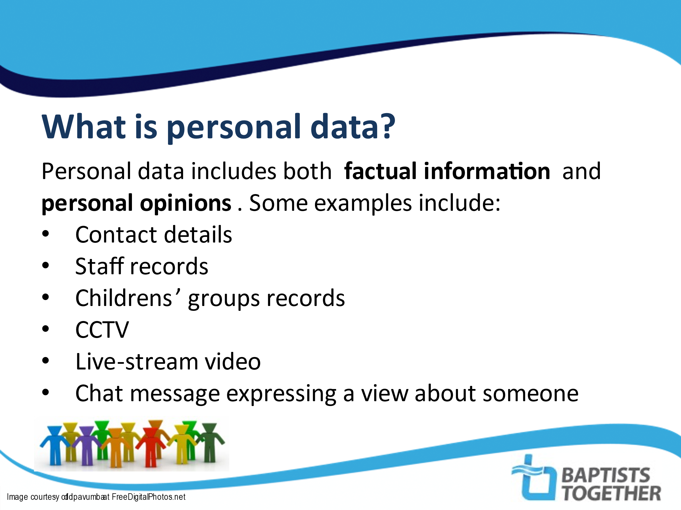 | SCRIPT:  (Read from slide)  SCRIPT: Again, just read from the slide  NOTES: Other things also count as ‘personal data’ but these are a list of things that are relevant for churches
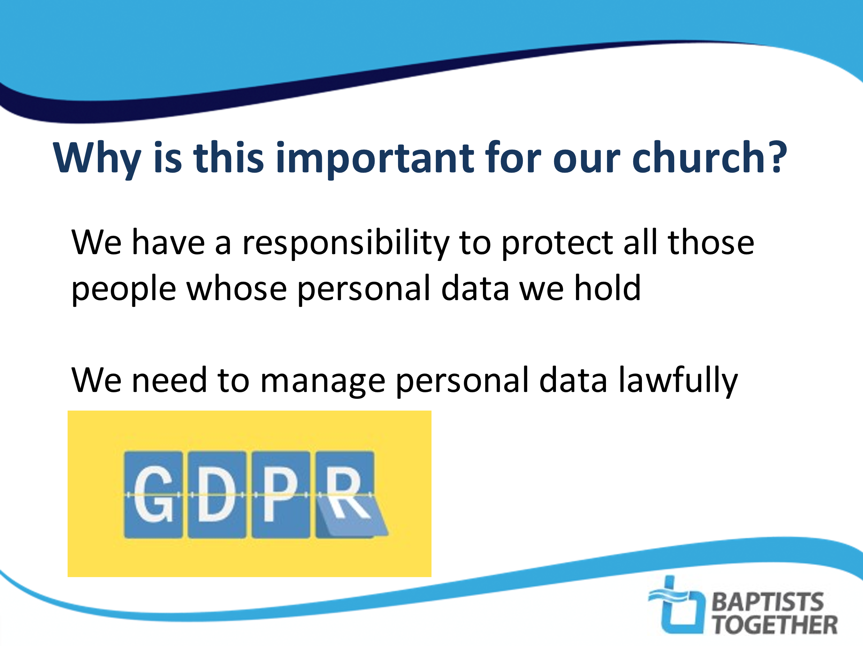 |  | SCRIPT: So – why is this important for us as a church? The most important reason is our responsibility to protect the people whose personal data we hold from misuse of that data – we need to ensure we don’t use the data we have in a way which would cause distress to people or be used in a way that they do not anticipate, such as being shared with third parties. Most of us will not have an issue with the way our church uses our data but some people will have concerns and it is important to be deal with people’s data fairly and appropriately.  The second reason is that it is the law and organisations that get it wrong could be fined. Individuals who are unhappy with the way their information is processed have the right to complain to the Information Commissioner’s Office (ICO). This could then be investigated and if an organisation is found to be in breach of this legislation then, depending on the severity of the offence, fines could be imposed.  NOTES: You might want to use some of the examples in the Appendix to explain why some people might be upset with the way the church uses their information (change names if necessary!)
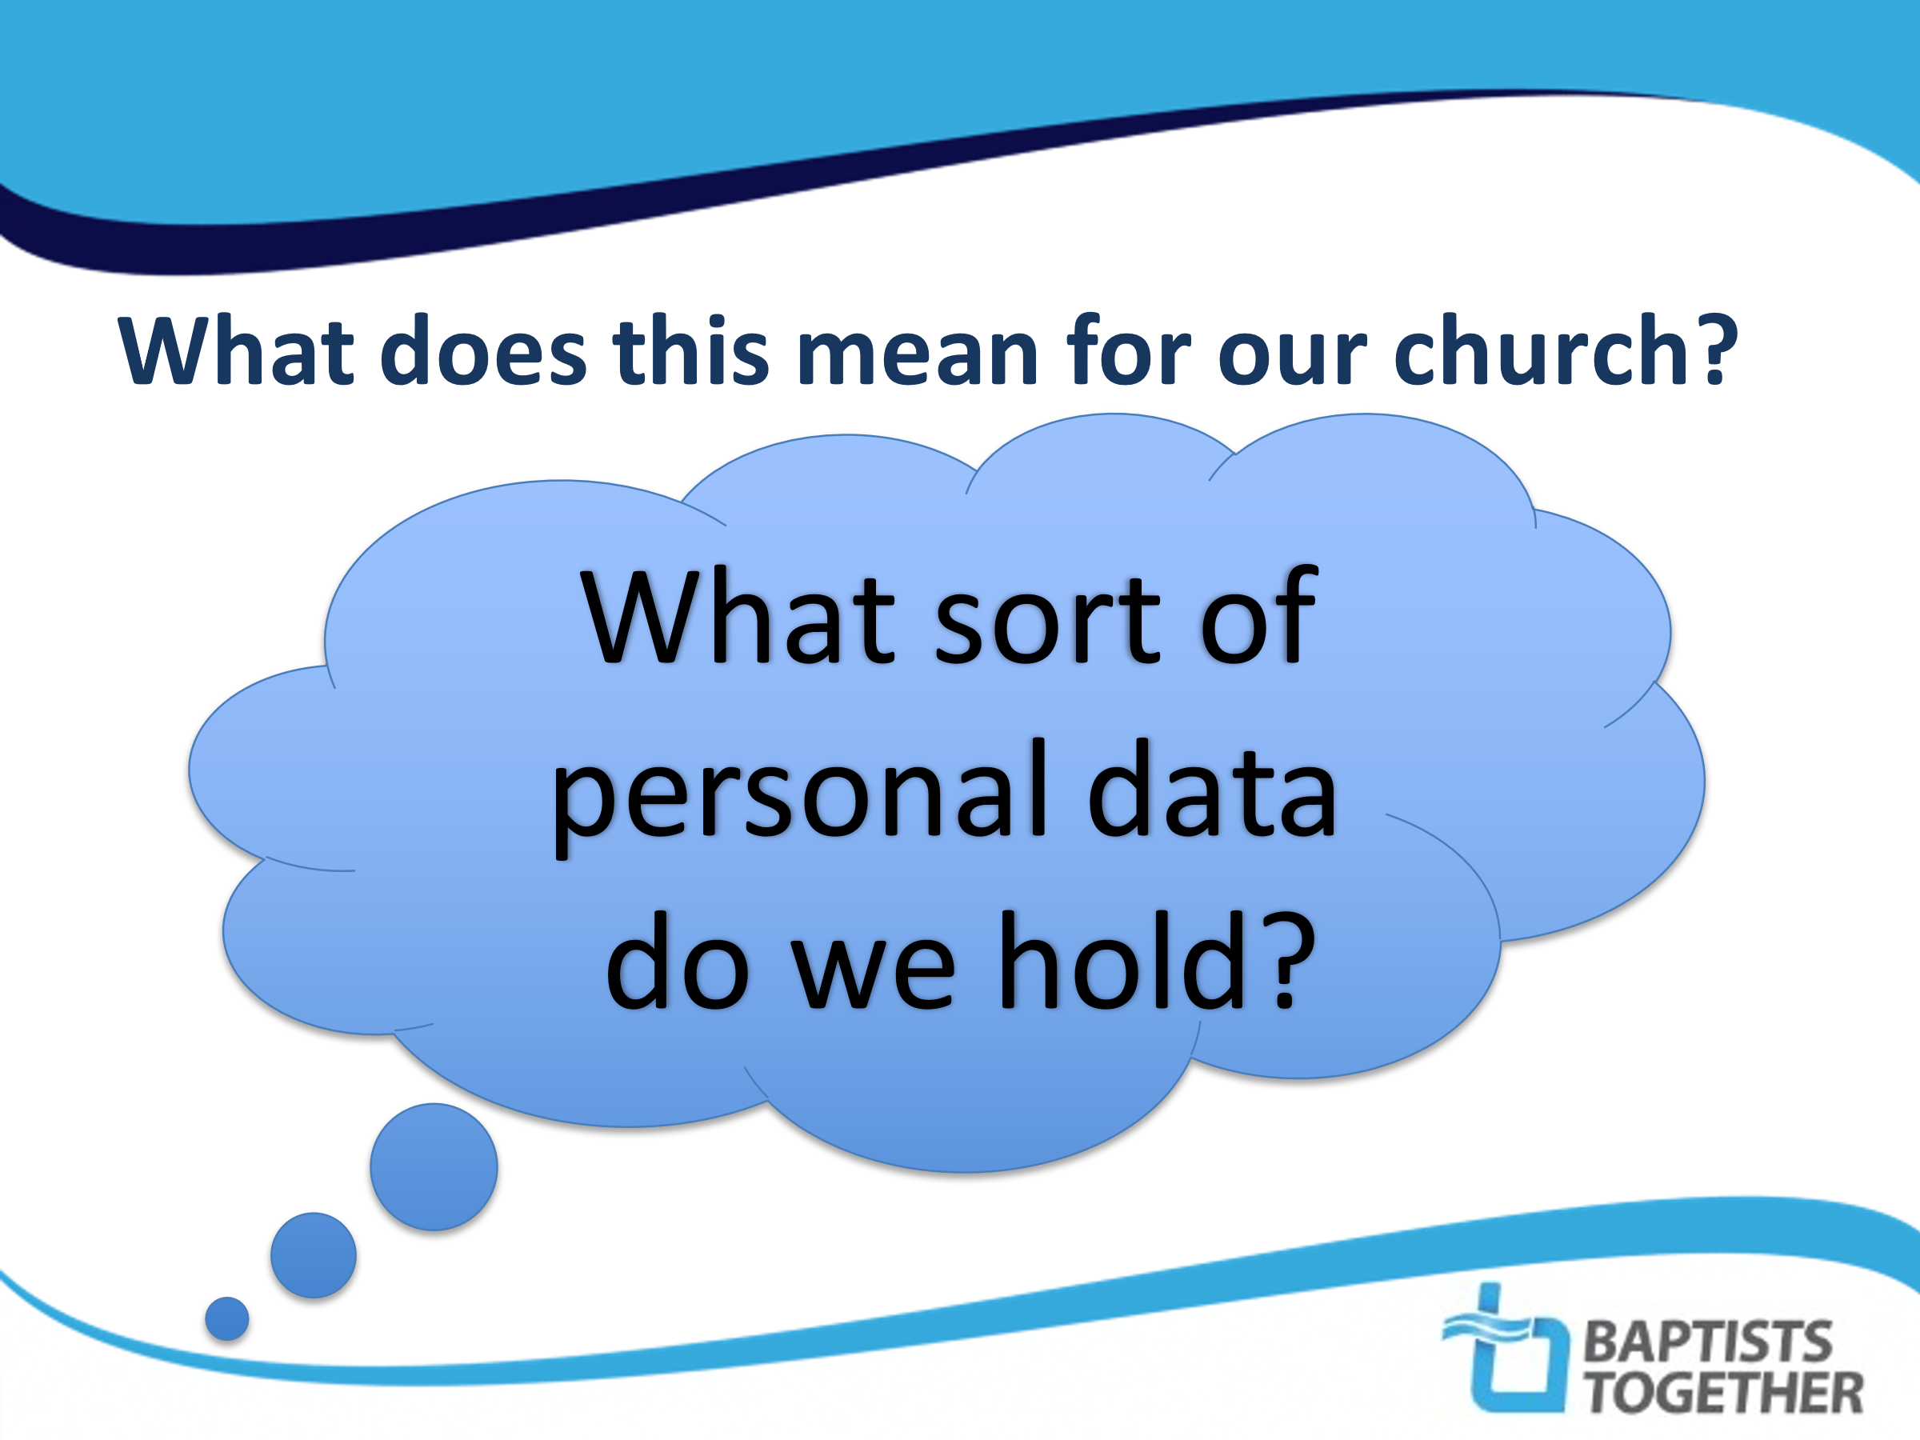 |  | NOTES  Ask the church meeting to break into small groups and think together about the sort of information which the church holds.  You could also ask them why they think the church holds that information and what we do with it.  Take feedback and then fill in any blanks – what have they not thought of?
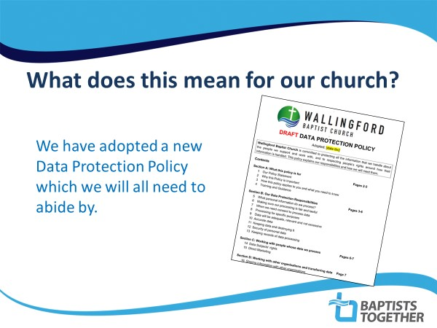 | NOTES  Please try and use a picture of your own church’s policy or your own church here!  Explain how people can get hold of a copy of the policy. You could produce a document which summarises the key points of the policy and hand this out
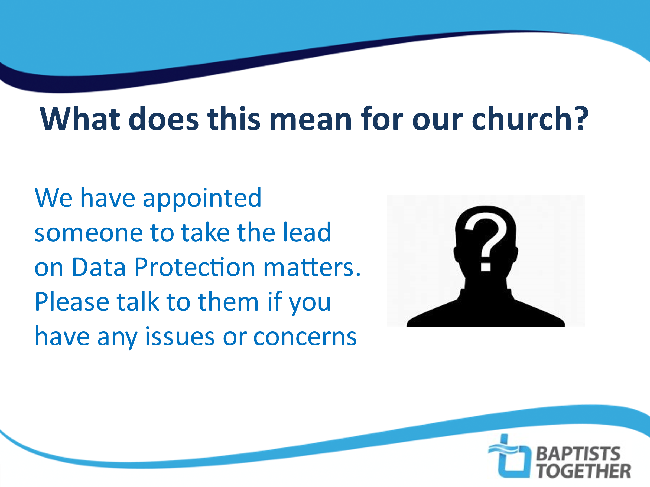 |  | NOTES  Use a picture of your own Data Protection Trustee (or equivalent)
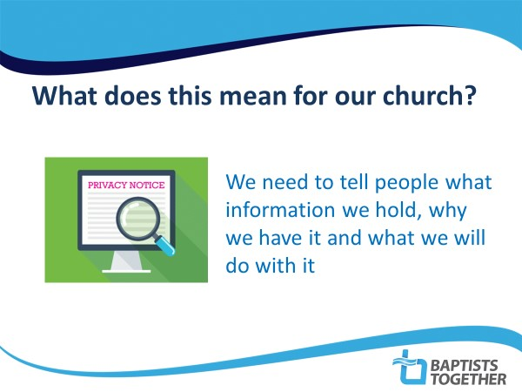 |  | SCRIPT: One of the key principles of Data Protection legislation is the importance of people knowing what information we hold about them, why we have it (lawful basis) and what we will do with it. The best way to do this is in something called a ‘Privacy Notice’ or ‘Privacy Statement’.  NOTES: Explain how you will be doing this in your church. You could add an extra slide with one of the Privacy Statements you will be using. Point out where the Privacy Statement can be found eg. on your website.
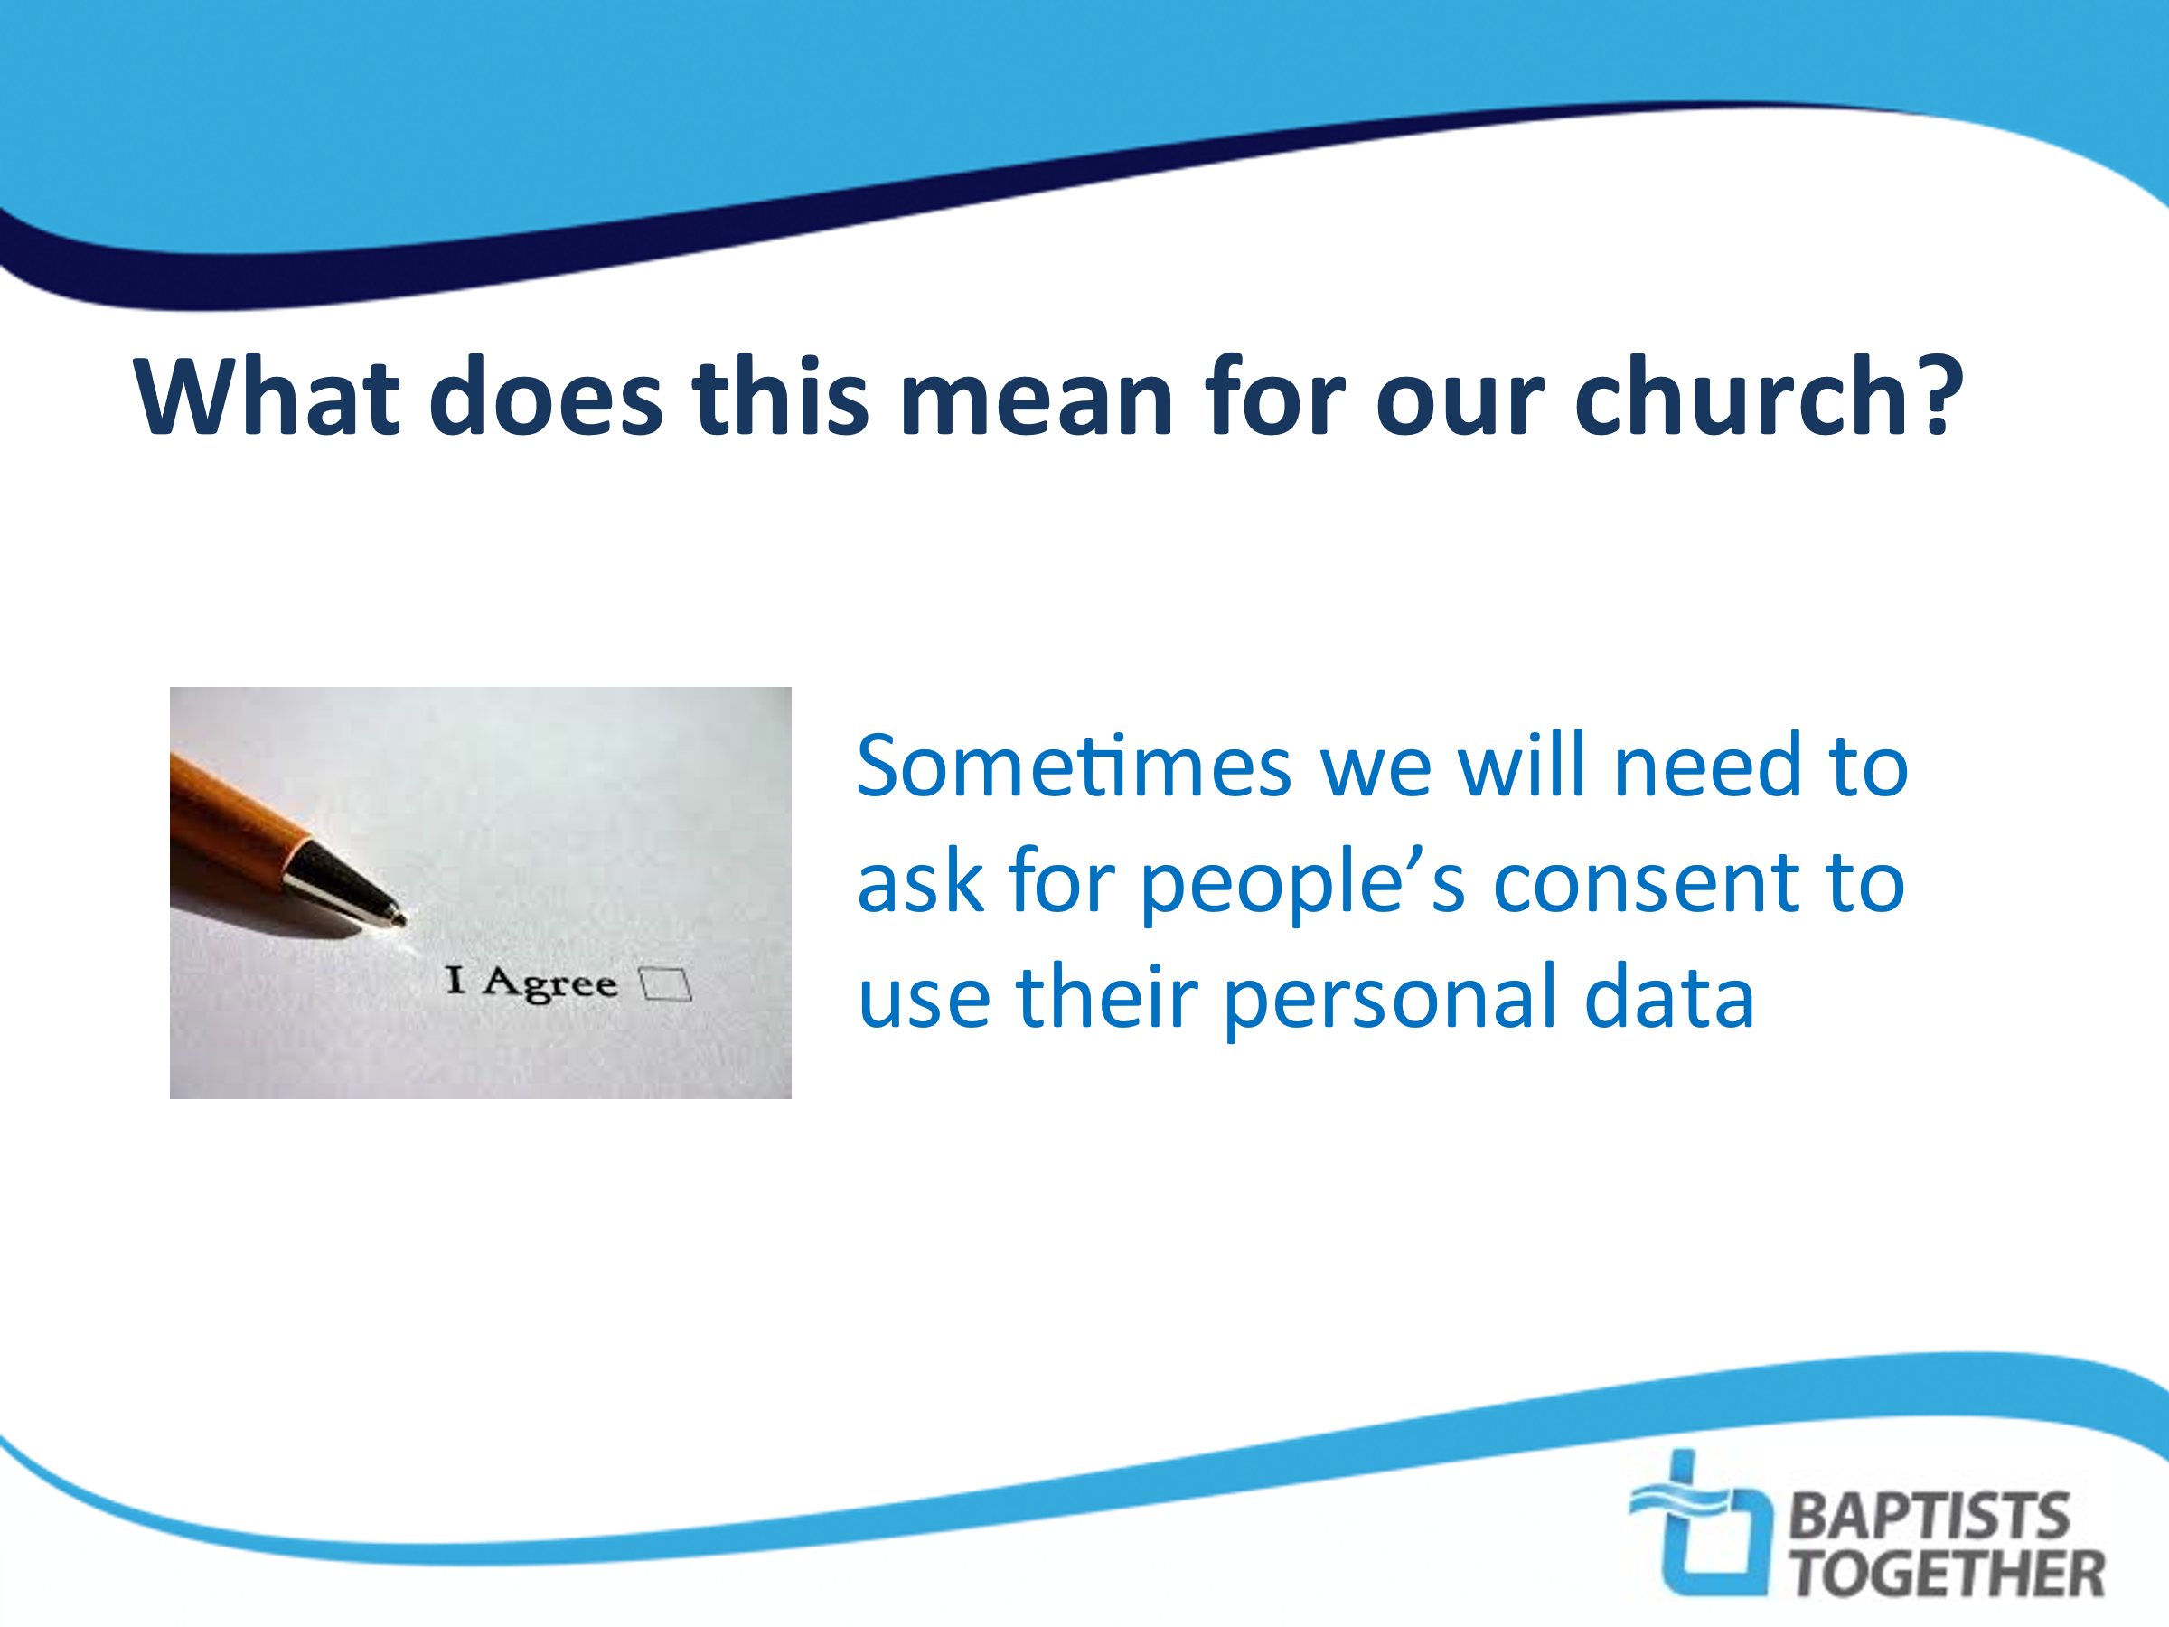 |  | SCRIPT: Under data protection law there are various legal grounds which organisations can use to allow them to process personal information.  The one which most people are aware of is ‘consent’ but this is not always the most appropriate one.  As a church we will generally use something called ‘legitimate Interest’ as our lawful basis. It is therefore in the church’s “legitimate interest” to hold the names and contact details of those in membership or regular contact with it. We do not therefore need individuals to give their specific consent for this.  However, we will ask people to give their consent for ….  NOTES: Explain when you will be asking for consent – e.g. publishing names and contact details in church directory, photos on website, direct marketing etc.
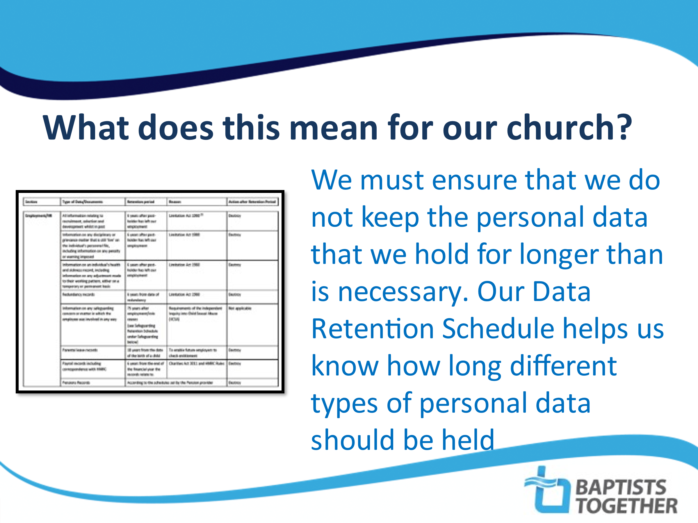  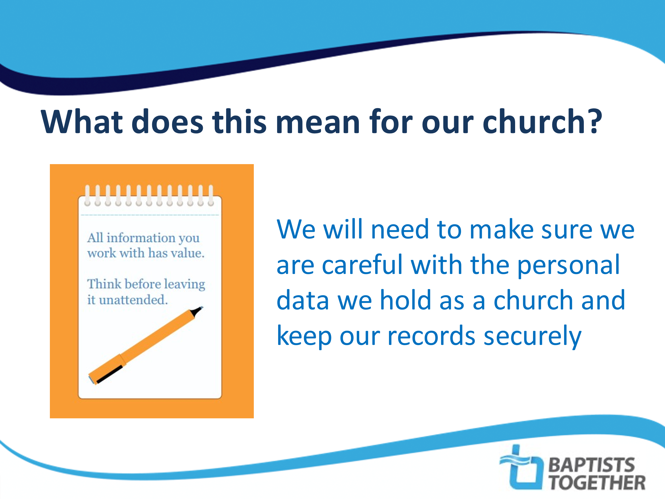 |  | SCRIPT: Security of personal data is also important – More care needs to be taken with sensitive information, such as….  NOTES: You could give some examples such as electronic safeguarding records, which should be password protected, backed-up regularly and only made accessible to those who need to access them such as the Designated Person for Safeguarding, minister, DBS verifier…  SCRIPT: Read from the slide. Some records have to be kept permanently of for longer periods of time eg. safeguarding records have to be kept for 75 years.  NOTES: You can use an image of your church’s own Data Retention Schedule here.  Explain where you can find a copy of the church’s Data Retention Schedule.
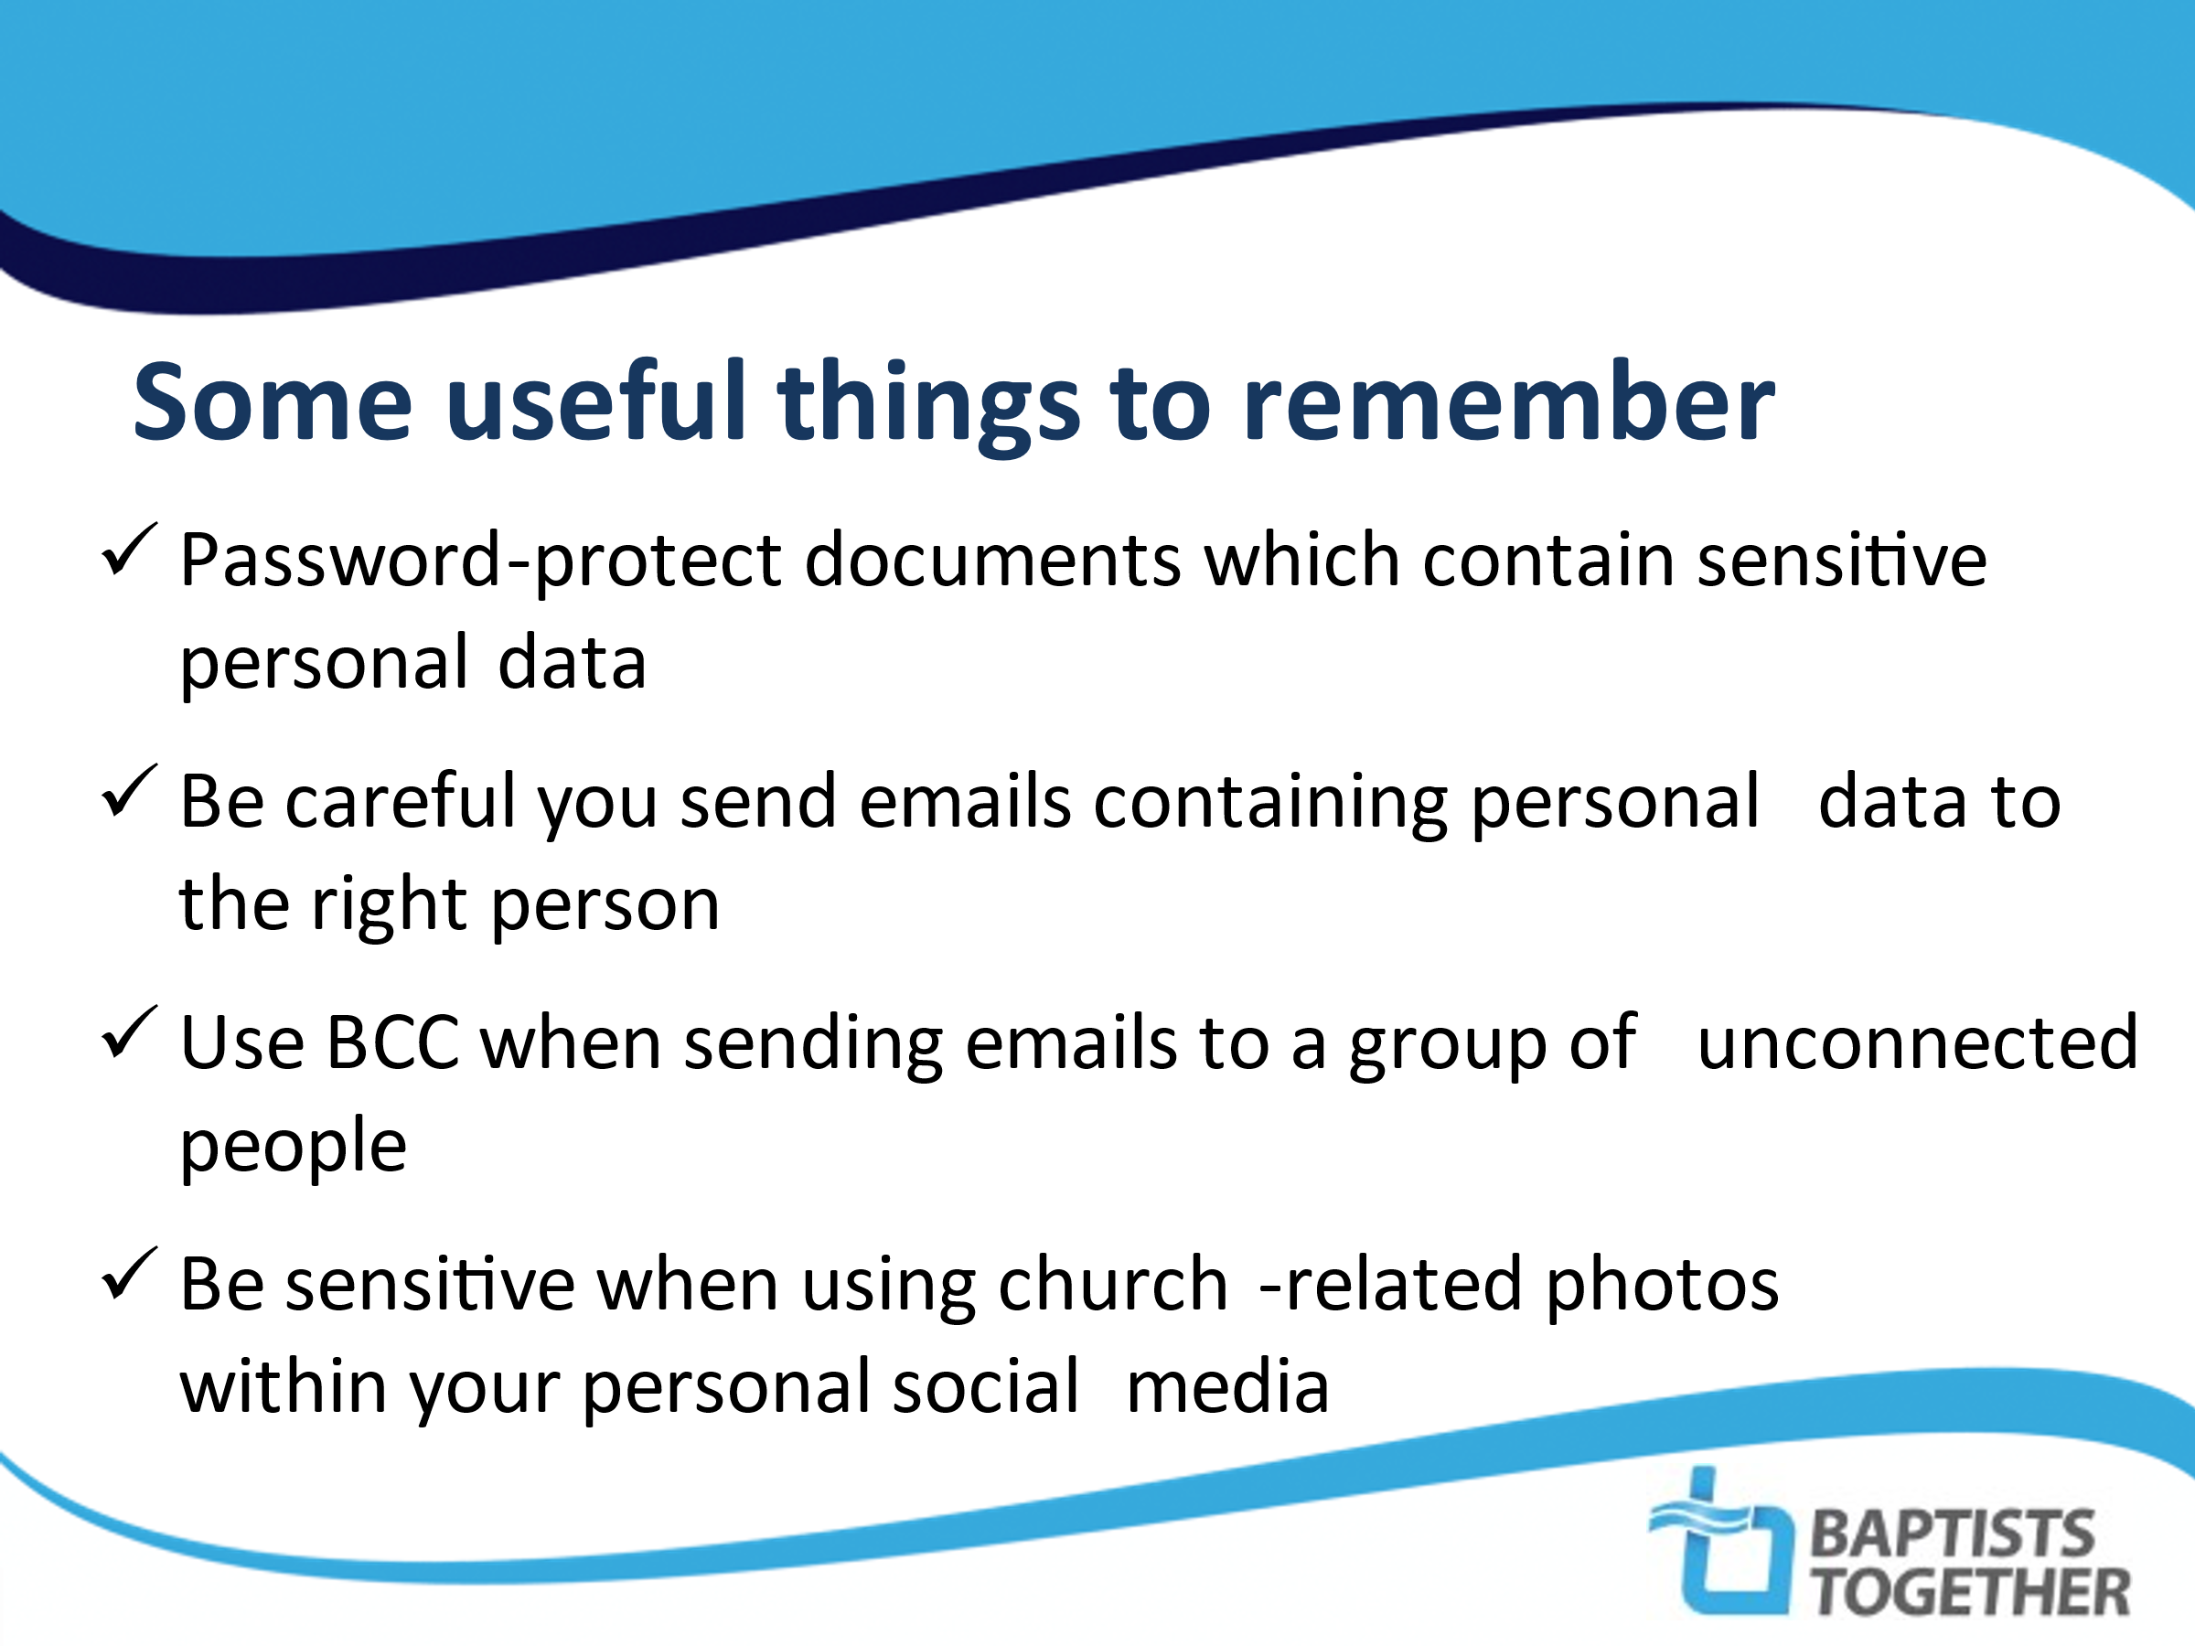 |  | SCRIPT: There are things all church members need to do to help protect people from the misuse of their data.  NOTES: Go through the points on this and the next slide.
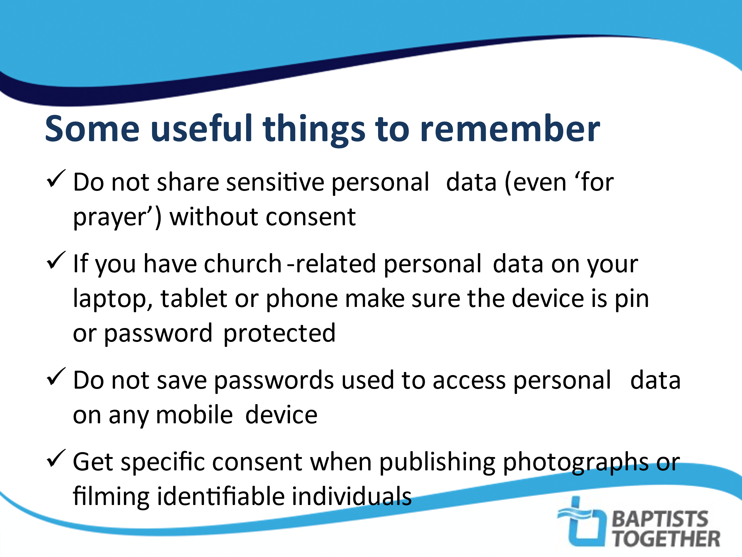 |  | NOTES: Feel free to add other bullet-points which are relevant to your church
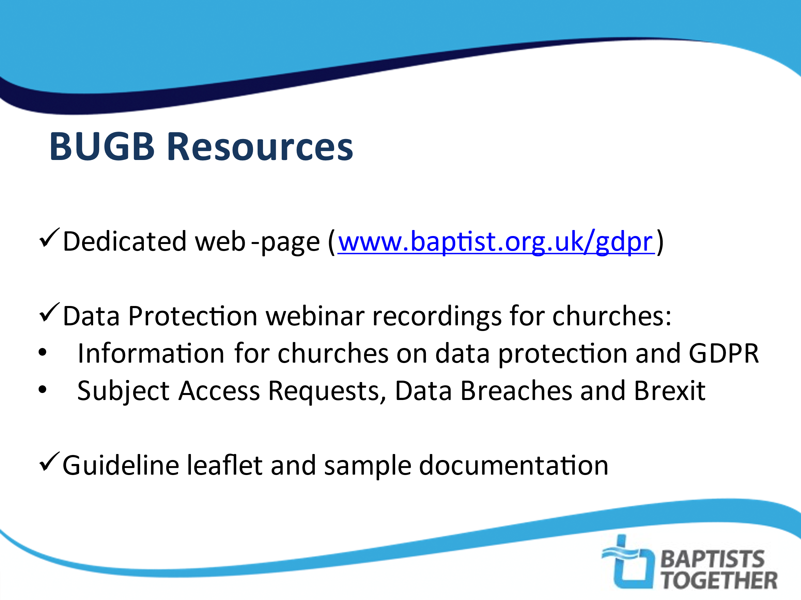 |  | SCRIPT: This has only been a fairly brief introduction to the subject of Data Protection and how it affects our church.  The Baptist Union have produced a number of resources to help their member churches and if anyone is interested in these they can be found on the BU website
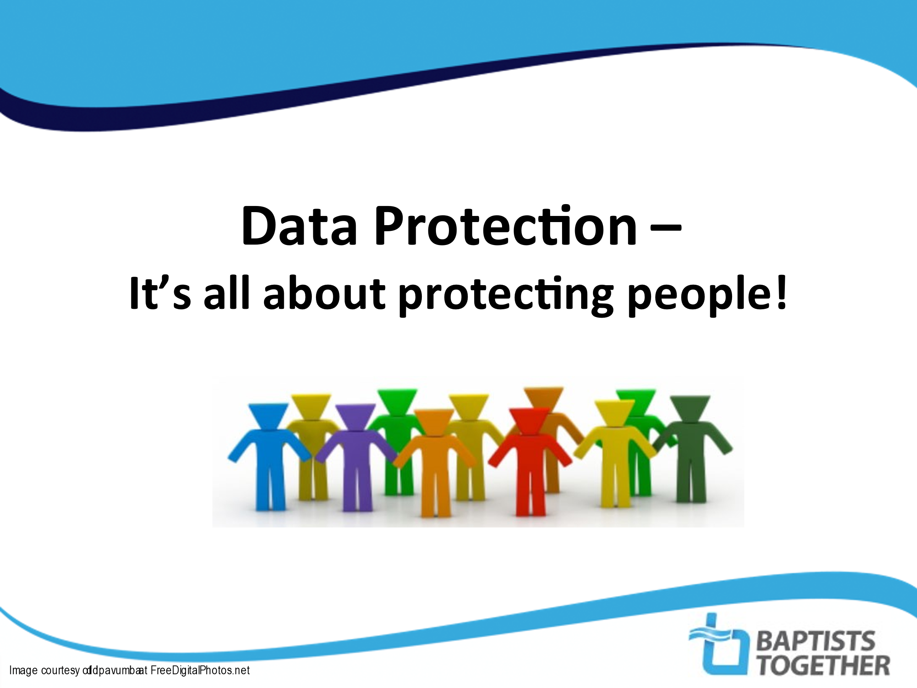 |  | SCRIPT: A final reminder why this is important.

